Частичный диктант 3 класс. Максимальный балл-8.
Время выполнения задания- 15 минут.
Винни-Пух рассказывает о себе и своих друзьях. Заполни пропуски в этой истории словами из списка.
Music, bike, sing, honey, fly, soccer, books, watch
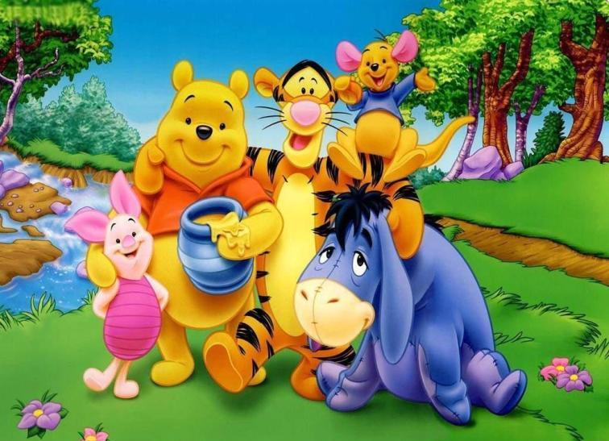
Good morning! My name is Winnie-the-Pooh. You can see me in the photo. I like (1) ______________and on Saturdays I (2)___________TV. My friend Piglet is nice and active. He rides a (3)____every day. My friend Rabbit is clever. He reads (4)_____and listens to (5)_____.
Look at my friend Tigger! He is strong! He plays (6)______on Sundays.
And have a look at our Eeyore! I like him. We (7)___a kite and (8) ____songs together on Tuesdays.
We are the best friends!

